TCP Control Flags and the Three-way Handshake

-Aayush Tyagi

* The Transport layer allows traffic to be directed to specific network applications. And the Application layer allows these applications to communicate in a way they understand.
* The transport layer has the ability to multiplex and demultiplex, which sets this layer apart from all others.
* Multiplexing in the transport layer means that nodes on the network have the ability to direct traffic toward many different receiving services.
* Demultiplexing is the same concept, just at the receiving end, it's taking traffic that's all aimed at the same node and delivering it to the proper receiving service.
* 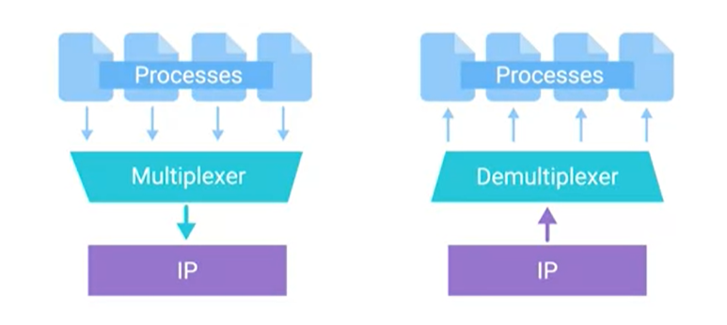
* A port is a 16-bit number that's used to direct traffic to specific services running on a networked computer.
* FTP is an older method used for transferring files from one computer to another, but you still see it in use today.
* A TCP segment is made up of a TCP header and a data section.
* 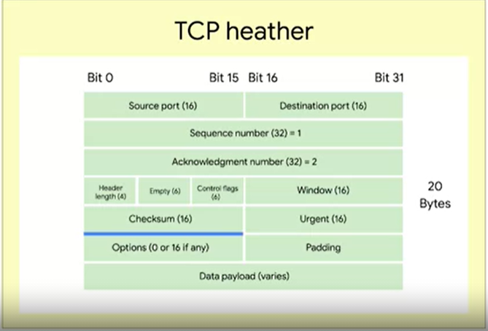
* A source port is a high numbered port chosen from a special section of ports known as ephemeral ports.
* Sequence Number: This is a 32-bit number that's used to keep track of where in a sequence of TCP segments this one is expected to be.
* The acknowledgment number is the number of the next expected segment.
* Data Offset Field: This field is a four-bit number that communicates how long the TCP header for this segment is.
* A TCP window specifies the range of sequence numbers that might be sent before an acknowledgement is required.
* TCP Checksum: It operates just like the checksum fields at the IP and Ethernet level.
* The Urgent pointer field is used in conjunction with one of the TCP control flags to point out particular segments that might be more important than others.
* Next up, we have the options field. Like the urgent pointer field, this is rarely used in the real world, but it's sometimes used for more complicated flow control protocols. Finally, we have some padding which is just a sequence of zeros to ensure that the data payload section begins at the expected location.
* Finally, we have some padding which is just a sequence of zeros to ensure that the data payload section begins at the expected location.